***Good Designs***

Car rental : Image used blends with color

Simple aligned buttons

Visible icons used for categories

Good design

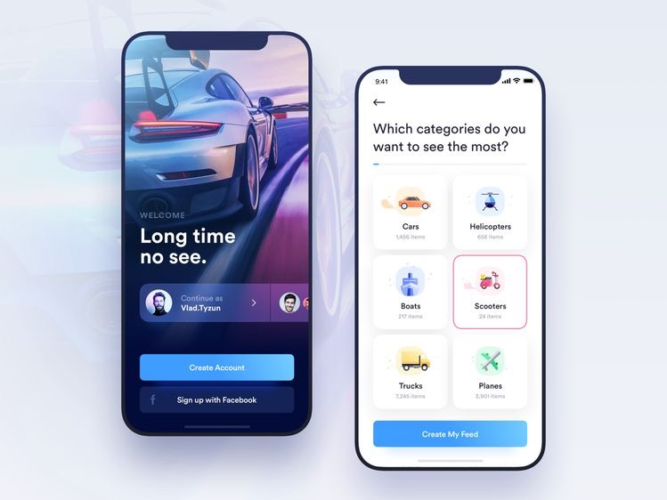

Food App: Simple presentable look

Blending colors

Nice images

Buttons used for categories with images

Good design

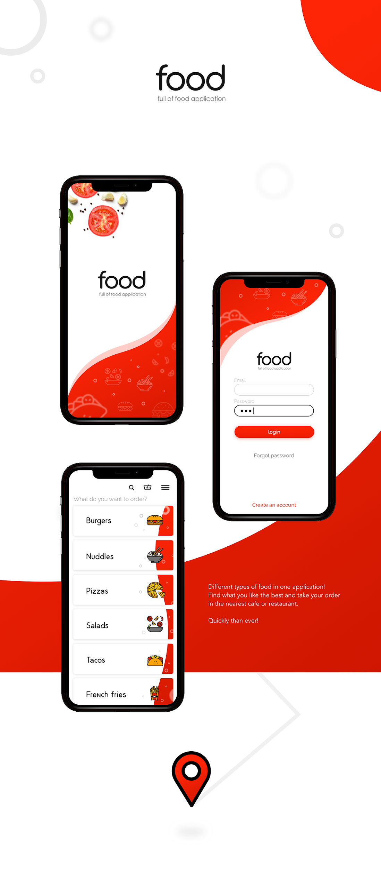

***Not so good***

Banking app: color on the first ui is too much

Make all ui the same in terms on color blending

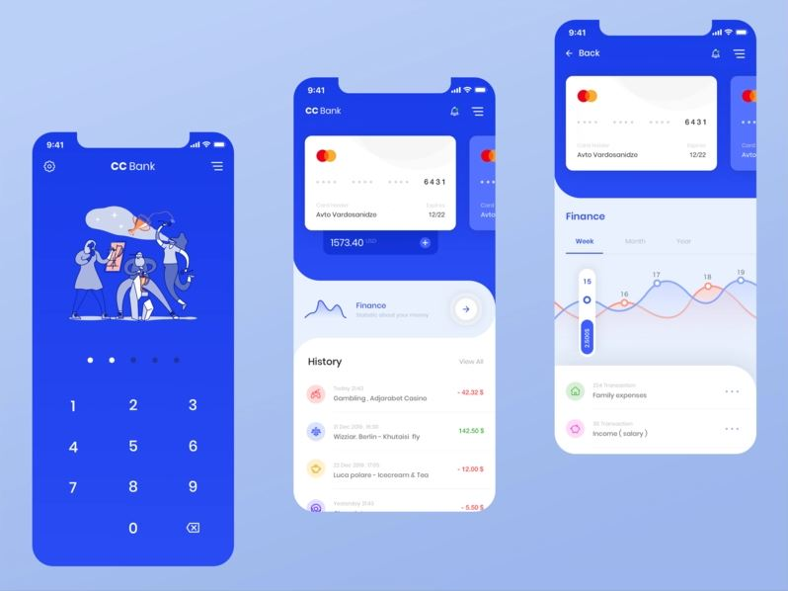

E-com app: dull on choice of color

No visual pictures

